Max Shi  
E 234  
Professor De Rosa  
November 18, 2020  
I pledge my honor that I have abided by the Stevens Honor System.

Homework 8  
Partner: Ashley McDermott

1. $$Δs_{piston}=s_{f}-s_{g} \\ Δs_{piston}=1.5302-7.1270=-5.5968\frac{kJ}{kg*K} \\ ΔQ-ΔW=ΔE, W=0, ΔQ=ΔE \\ Δq=Δu+ΔPE+ΔKE=Δu=-u_{fg}=-2024.6\frac{kJ}{kg} \\ Δs_{surroundings}=\frac{-q}{90+273.15}=\frac{2024.6}{90+273.15}=5.575\frac{kJ}{kg*K} \\ Δs_{gen}=Δs_{surroundings}+Δs_{piston}=-5.5968+5.575=-0.0217\frac{kJ}{kg*K}$$ Negative entropy generation is impossible, so this process is impossible.
2. $$ΔQ+ΔW=ΔE \\ ΔE=0, isothermal ideal gas \\ ΔQ=-ΔW \\ Q_{out}=W_{in} \\ \left(a\right) Q_{out}=0.1 kJ \\ V_{1}={0.06}^{2}*π*0.20=0.00226 m^{3} \\ PV\ln{\frac{V_{2}}{V_{1}}}=W_{b}⇒0.1=100*0.00226*\ln{\frac{V_{2}}{0.00226}} \\ \left(b\right) V_{2}=0.003518 m^{3} \\ P_{1}V_{1}=P_{2}V_{2} \\ 100*0.00226=0.003518*P_{2} \\ \left(b\right) P_{2}=64.24 kPa \\ ΔS=\frac{ΔQ}{T}=\frac{-0.1}{273.15+24}=-0.000337\frac{kJ}{K}$$ This value is negative because heat is leaving the gas. In the system as a whole, the heat goes into the surroundings, which will have a positive entropy value. The system as a whole needs to have a positive entropy change, but not the gas itself.
3. 2. At 50 kPa, the sf < sin = 7.0910 < sg, so there would be a saturated mixture at the exit.  
      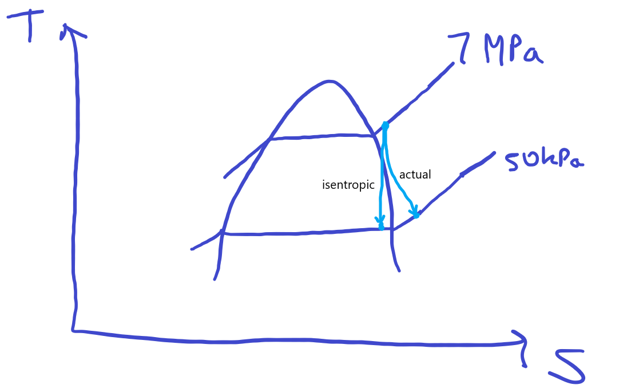
4. 3. From the previous part, V2 is 545.29 m/s.